**BOOKSTORE**

**Aim : CREATE A WEBSITE FOR BOOKSTORE USING HTML.**

**Bookstore:**

**1.Homepage**

**2.About**

**3.Book Category**

**4.Our Books**

**5.Best Selling**

**6.New Releases**

**7.SignUp**

**8.Login**

**HOMEPAGE:**

**Code-**

**<!DOCTYPE html>**

**<html>**

**<head>**

**<title>Home</title>**

**<style>a{text-decoration:none;}</style>**

**</head>**

**<body>**

**<table style="width:100%">**

**<tr>**

**<td colspan="8" align="center"><img src="images/logo.jpg" style="height:100px;"></td>**

**</tr>**

**<tr style="background:wheat;">**

**<td align="center" style="padding:10px;"><a href="homepage.html">Home</a></td>**

**<td align="center" style="padding:10px;"><a href="about.html">About</a></td>**

**<td align="center" style="padding:10px;"><a href="category.html">Book Categories</a></td>**

**<td align="center" style="padding:10px;"><a href="books.html">Our Books</a></td>**

**<td align="center" style="padding:10px;"><a href="bestselling.html">Best Selling</a></td>**

**<td align="center" style="padding:10px;"><a href="new.html">New Releases</a></td>**

**<td align="center" style="padding:10px;"><a href="signup.html">Register</a></td>**

**<td align="center" style="padding:10px;"><a href="login.html">Login</a></td>**

**</tr>**

**<tr>**

**<td colspan="8"><img src="images/homepage/banner.jpg" style="width:100%;"></td>**

**</tr>**

**<tr>**

**<td colspan="8" style="padding:20px 10px;"><h2>Book Genre</h2></td>**

**</tr>**

**<tr>**

**<td colspan="2" style="padding:5px 10px;">**

**<img src="images/homepage/Art.jpg" style="width:330px; height:300px;">**

**<h3>Art & Photography</h3>**

**</td>**

**<td colspan="2" style="padding:5px 10px;">**

**<img src="images/homepage/crime.jpg" style="width:330px; height:300px;">**

**<h3>Crime & Thriller</h3>**

**</td>**

**<td colspan="2" style="padding:5px 10px;">**

**<img src="images/homepage/sci.jpg" style="width:330px; height:300px;">**

**<h3>Science Fiction</h3>**

**</td>**

**<td colspan="2" style="padding:5px 10px;">**

**<img src="images/homepage/horror.jpg" style="width:330px; height:300px;">**

**<h3>Fantasy & Horror</h3>**

**</td>**

**</tr>**

**<tr>**

**<td colspan="8" style="padding:20px 10px;"><h2>Best Selling Books</h2></td>**

**</tr>**

**<tr>**

**<td style="padding:5px 10px;">**

**<img src="images/homepage/trend1.jpg" style="height:200px;">**

**<h4>The Tale of Two Cities</h4>**

**</td>**

**<td style="padding:5px 10px;">**

**<img src="images/homepage/trend2.jpg" style="height:200px;">**

**<h4>The Hobbit</h4>**

**</td>**

**<td style="padding:5px 10px;">**

**<img src="images/homepage/trend3.jpg" style="height:200px;">**

**<h4>The Lords of The Rings</h4>**

**</td>**

**<td style="padding:5px 10px;">**

**<img src="images/homepage/trend4.jpg" style="height:200px;">**

**<h4>It Ends With US</h4>**

**</td>**

**<td style="padding:5px 10px;">**

**<img src="images/homepage/trend5.jpg" style="height:200px;">**

**<h4>Breath</h4>**

**</td>**

**<td style="padding:5px 10px;">**

**<img src="images/homepage/trend6.jpg" style="height:200px;">**

**<h4>This Is Not Your Story</h4>**

**</td>**

**<td style="padding:5px 10px;">**

**<img src="images/homepage/trend7.jpg" style="height:200px;">**

**<h4>The Silent Patient</h4>**

**</td>**

**<td style="padding:5px 10px;">**

**<img src="images/homepage/trend8.jpg" style="height:200px;">**

**<h4>The Hidden Hindu</h4>**

**</td>**

**</tr>**

**<tr>**

**<td colspan="8" style="padding:20px 10px;"><h2>Authors</h2></td>**

**</tr>**

**<tr>**

**<td colspan="2" style="padding:5px 10px;">**

**<img src="images/homepage/author1.jpg" style="width:200px; height:200px;">**

**<h3>Chetan Bhagat</h3>**

**</td>**

**<td colspan="2" style="padding:5px 10px;">**

**<img src="images/homepage/author2.jpg" style="width:200px; height:200px;">**

**<h3>Jhumpa Lahiri</h3>**

**</td>**

**<td colspan="2" style="padding:5px 10px;">**

**<img src="images/homepage/author3.jpg" style="width:200px; height:200px;">**

**<h3>Nadine Gordimer</h3>**

**</td>**

**<td colspan="2" style="padding:5px 10px;">**

**<img src="images/homepage/author4.jpg" style="width:200px; height:200px;">**

**<h3>James Joyce</h3>**

**</td>**

**</tr>**

**</tr>**

**</table>**

**<footer style="text-align: left;">**

**<p style="background:lavenderblush;">**

**𝓣𝓱𝓮 𝓢𝓽𝓸𝓻𝔂 𝓖𝓵𝓸𝓻𝔂 <br>The Story Glory is the world’s leading Bookstore<br> having millions of book available.**

**<br>**

**<a href="https://www.instagram.com/pankajdagar_/"><img src="images/insta.jpg" alt="insta" height="20"width="20"></a>**

**<a href="https://github.com/Pankajdagar777"><img src="images/git.jpg" alt="github" height="20"width="20"></a>**

**<a href="https://m.facebook.com/"><img src="images/fb.jpg" alt="facebook" height="20"width="20"></a>**

**<br>   © 2023 The story Glory. All rights reserved.**

**</footer>**

**</body>**

**</html>**

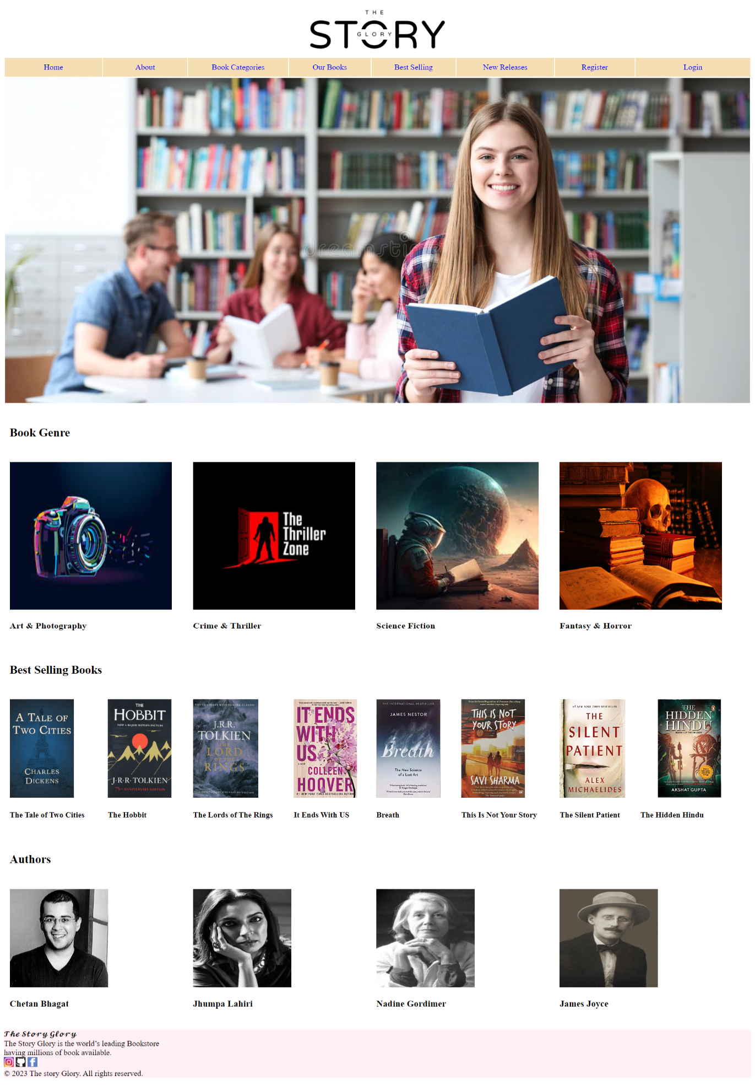

**2.ABOUT-**

**Code:**

**<!DOCTYPE html>**

**<html>**

**<head>**

**<title>Home</title>**

**<style>a {text-decoration:none;}</style>**

**</head>**

**<body>**

**<table style="width:100%">**

**<tr>**

**<td colspan="8" align="center"><img src="images/logo.jpg" style="height:100px;"></td>**

**</tr>**

**<tr style="background:wheat;">**

**<td align="center" style="padding:10px;"><a href="homepage.html">Home</a></td>**

**<td align="center" style="padding:10px;"><a href="about.html">About</a></td>**

**<td align="center" style="padding:10px;"><a href="category.html">Book Categories</a></td>**

**<td align="center" style="padding:10px;"><a href="books.html">Our Books</a></td>**

**<td align="center" style="padding:10px;"><a href="bestselling.html">Best Selling</a></td>**

**<td align="center" style="padding:10px;"><a href="new.html">New Releases</a></td>**

**<td align="center" style="padding:10px;"><a href="signup.html">Register</a></td>**

**<td align="center" style="padding:10px;"><a href="login.html">Login</a></td>**

**</tr>**

**<tr>**

**<td colspan="8"><img src="images/banner1.jpg" style="width:100%;"></td>**

**</tr>**

**<tr>**

**<td colspan="8" style="padding:20px 10px;"><h2>About</h2>**

**<p>**

**Open Library is growing faster than ever before—and we need your help this Tuesday.**

**We build and maintain all our own systems rather than contracting them out, and we do this without charging for access,**

**selling user data, or running ads. Instead, the Internet Archive (which runs this project) depends**

**on donations averaging just $25.51 to fund infrastructure needs. We'd be deeply grateful if you'd join**

**the one in a thousand users that support us financially.**

**</p>**

**<p>**

**Right now, we have a 2-to-1 Matching Gift Campaign, tripling the impact of every donation.**

**We understand that not everyone can donate right now, but if you can afford to contribute, we promise it will be put to good use.**

**Access to knowledge is more crucial than ever—so if you find all these bits and bytes useful, please pitch in.**

**</p>**

**</td>**

**</tr>**

**</table>**

**<footer style="text-align: left;">**

**<p style="background:lavenderblush;">**

**𝓣𝓱𝓮 𝓢𝓽𝓸𝓻𝔂 𝓖𝓵𝓸𝓻𝔂 <br>The Story Glory is the world’s leading Bookstore<br> having millions of book available.**

**<br>**

**<a href="https://www.instagram.com/pankajdagar_/"><img src="images/insta.jpg" alt="insta" height="20"width="20"></a>**

**<a href="https://github.com/Pankajdagar777"><img src="images/git.jpg" alt="github" height="20"width="20"></a>**

**<a href="https://m.facebook.com/"><img src="images/fb.jpg" alt="facebook" height="20"width="20"></a>**

**<br>   © 2023 The story Glory. All rights reserved.**

**</footer>**

**</body>**

**</html>**

**Output:**

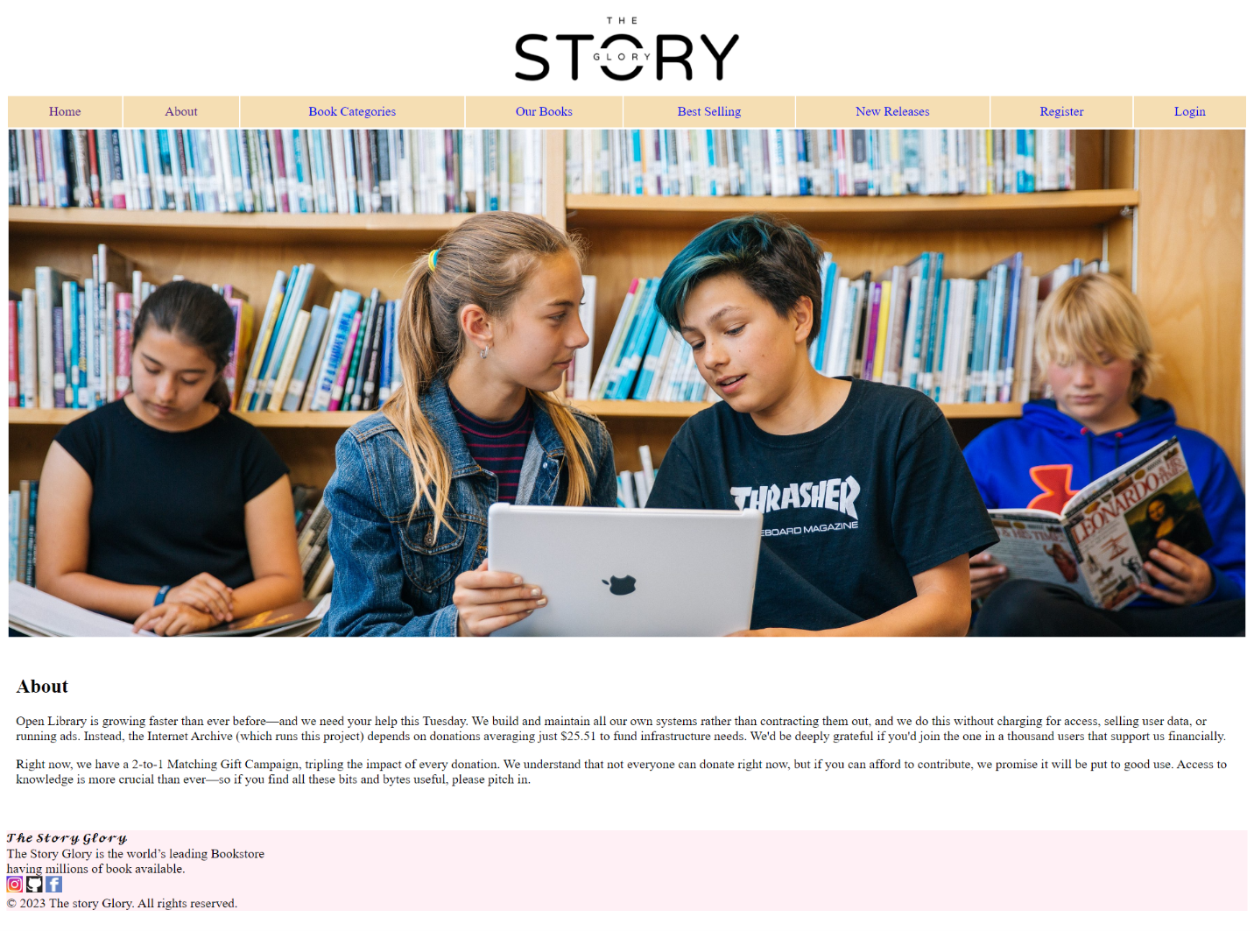

**3.Book Category:**

**Code-**

**<!DOCTYPE html>**

**<html>**

**<head>**

**<title>Book Categories</title>**

**<style>a{text-decoration:none;}</style>**

**</head>**

**<body>**

**<table style="width:100%">**

**<tr>**

**<td colspan="8" align="center"><img src="images/logo.jpg" style="height:100px;"></td>**

**</tr>**

**<tr style="background:wheat;">**

**<td align="center" style="padding:10px;"><a href="homepage.html">Home</a></td>**

**<td align="center" style="padding:10px;"><a href="about.html">About</a></td>**

**<td align="center" style="padding:10px;"><a href="category.html">Book Categories</a></td>**

**<td align="center" style="padding:10px;"><a href="books.html">Our Books</a></td>**

**<td align="center" style="padding:10px;"><a href="bestselling.html">Best Selling</a></td>**

**<td align="center" style="padding:10px;"><a href="new.html">New Releases</a></td>**

**<td align="center" style="padding:10px;"><a href="signup.html">Register</a></td>**

**<td align="center" style="padding:10px;"><a href="login.html">Login</a></td>**

**</tr>**

**<tr>**

**<td colspan="8"><img src="images/category/banner3.jpg" style="width:100%;"></td>**

**</tr>**

**<tr>**

**<td colspan="8" style="padding:20px 10px;"><h2>Book Categories</h2></td>**

**</tr>**

**<tr>**

**<td colspan="2" style="padding:5px 10px;">**

**<img src="images/category/cat1.jpg" style="width:330px; height:300px;">**

**<h3>Art & Photography</h3>**

**</td>**

**<td colspan="2" style="padding:5px 10px;">**

**<img src="images/category/cat2.jpg" style="width:330px; height:300px;">**

**<h3>Crime & Thriller</h3>**

**</td>**

**<td colspan="2" style="padding:5px 10px;">**

**<img src="images/category/cat3.jpg" style="width:330px; height:300px;">**

**<h3>Science Fiction</h3>**

**</td>**

**<td colspan="2" style="padding:5px 10px;">**

**<img src="images/category/cat4.jpg" style="width:330px; height:300px;">**

**<h3>Fantasy & Horror</h3>**

**</td>**

**</tr>**

**<tr>**

**<td colspan="2" style="padding:5px 10px;">**

**<img src="images/category/cat5.jpg" style="width:330px; height:300px;">**

**<h3>Biography</h3>**

**</td>**

**<td colspan="2" style="padding:5px 10px;">**

**<img src="images/category/cat6.jpg" style="width:330px; height:300px;">**

**<h3>Food & Drink</h3>**

**</td>**

**<td colspan="2" style="padding:5px 10px;">**

**<img src="images/category/cat7.jpg" style="width:330px; height:300px;">**

**<h3> Hobbies</h3>**

**</td>**

**<td colspan="2" style="padding:5px 10px;">**

**<img src="images/category/cat8.jpg" style="width:330px; height:300px;">**

**<h3>Graphic</h3>**

**</td>**

**</tr>**

**</table>**

**<footer style="text-align: left;">**

**<p style="background:lavenderblush;">**

**𝓣𝓱𝓮 𝓢𝓽𝓸𝓻𝔂 𝓖𝓵𝓸𝓻𝔂 <br>The Story Glory is the world’s leading Bookstore<br> having millions of book available.**

**<br>**

**<a href="https://www.instagram.com/pankajdagar_/"><img src="images/insta.jpg" alt="insta" height="20"width="20"></a>**

**<a href="https://github.com/Pankajdagar777"><img src="images/git.jpg" alt="github" height="20"width="20"></a>**

**<a href="https://m.facebook.com/"><img src="images/fb.jpg" alt="facebook" height="20"width="20"></a>**

**<br>   © 2023 The story Glory. All rights reserved.**

**</footer>**

**</body>        </html>**

**Output:**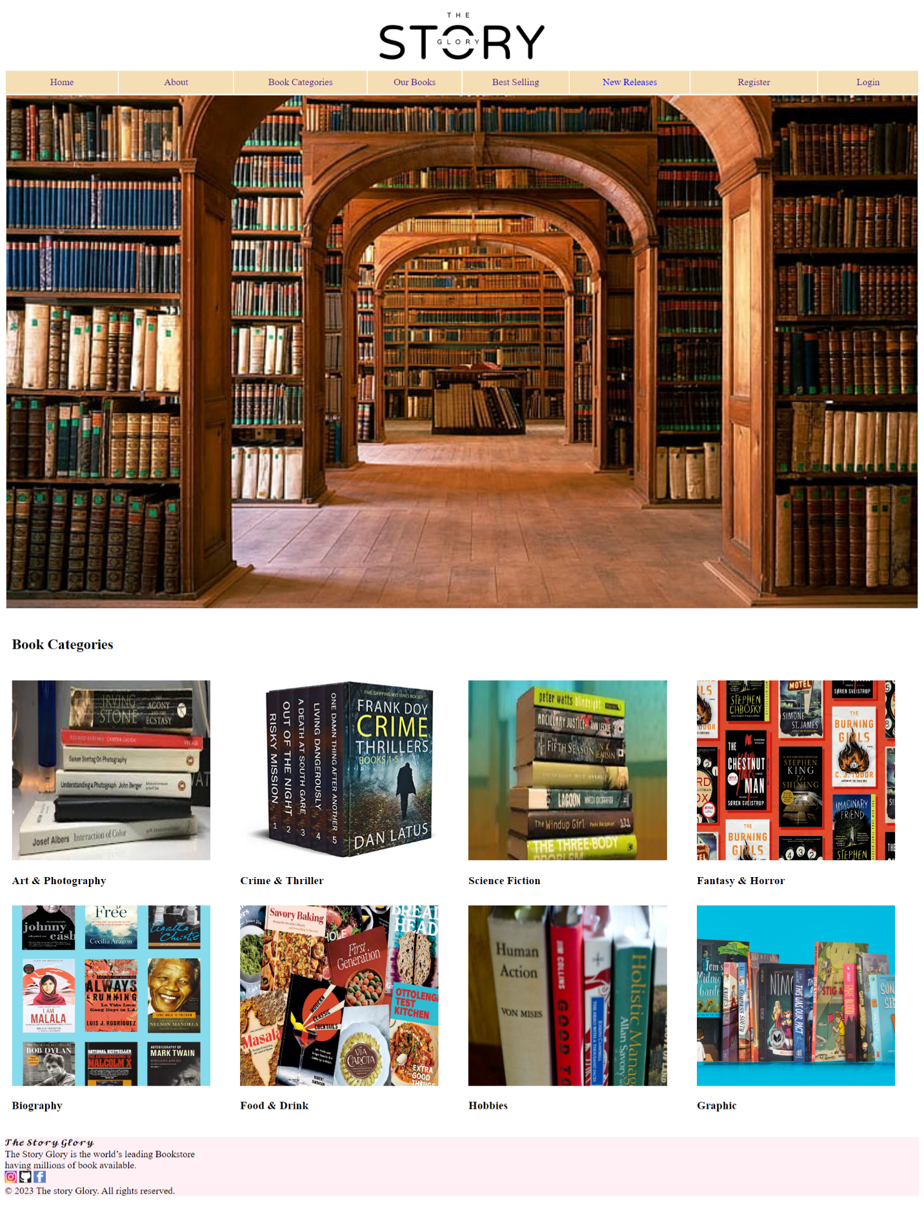

**4.OUR BOOKS:**

**Code-**

**<!DOCTYPE html>**

**<html>**

**<head>**

**<title>Home</title>**

**<style>a{text-decoration:none;}</style>**

**</head>**

**<body>**

**<table style="width:100%">**

**<tr>**

**<td colspan="8" align="center"><img src="images/logo.jpg" style="height:100px;"></td>**

**</tr>**

**<tr style="background:wheat;">**

**<td align="center" style="padding:10px;"><a href="homepage.html">Home</a></td>**

**<td align="center" style="padding:10px;"><a href="about.html">About</a></td>**

**<td align="center" style="padding:10px;"><a href="category.html">Book Categories</a></td>**

**<td align="center" style="padding:10px;"><a href="books.html">Our Books</a></td>**

**<td align="center" style="padding:10px;"><a href="bestselling.html">Best Selling</a></td>**

**<td align="center" style="padding:10px;"><a href="new.html">New Releases</a></td>**

**<td align="center" style="padding:10px;"><a href="signup.html">Register</a></td>**

**<td align="center" style="padding:10px;"><a href="login.html">Login</a></td>**

**</tr>**

**<tr>**

**<td colspan="8" style="padding:20px 10px;"><h2>Our Books</h2></td>**

**</tr>**

**<tr>**

**<td style="padding:5px 10px;">**

**<img src="images/books/book1.jpg" style="height:200px;">**

**<h4>Mill Flat Design</h4>**

**</td>**

**<td style="padding:5px 10px;">**

**<img src="images/books/book2.jpg" style="height:200px;">**

**<h4>Eco Flat Design</h4>**

**</td>**

**<td style="padding:5px 10px;">**

**<img src="images/books/book3.jpg" style="height:200px;">**

**<h4>Notes Flat Design</h4>**

**</td>**

**<td style="padding:5px 10px;">**

**<img src="images/books/book4.jpg" style="height:200px;">**

**<h4>Drive Safely, No Bumping</h4>**

**</td>**

**<td style="padding:5px 10px;">**

**<img src="images/books/book5.jpg" style="height:200px;">**

**<h4>Photo Flat Design</h4>**

**</td>**

**<td style="padding:5px 10px;">**

**<img src="images/books/book6.jpg" style="height:200px;">**

**<h4>Learn Spanish</h4>**

**</td>**

**<td style="padding:5px 10px;">**

**<img src="images/books/book7.jpg" style="height:200px;">**

**<h4>Breaking the habit of being Yourself</h4>**

**</td>**

**<td style="padding:5px 10px;">**

**<img src="images/books/book8.jpg" style="height:200px;">**

**<h4>The Princess Bride</h4>**

**</td>**

**</tr>**

**<tr>**

**<td style="padding:5px 10px;">**

**<img src="images/books/book9.jpg" style="height:200px;">**

**<h4>Matisse on Art</h4>**

**</td>**

**<td style="padding:5px 10px;">**

**<img src="images/books/book10.jpg" style="height:200px;">**

**<h4>Lori Foster</h4>**

**</td>**

**<td style="padding:5px 10px;">**

**<img src="images/books/book11.jpg" style="height:200px;">**

**<h4>Shaedes of Gray</h4>**

**</td>**

**<td style="padding:5px 10px;">**

**<img src="images/books/book12.jpg" style="height:200px;">**

**<h4>Slave to Love</h4>**

**</td>**

**<td style="padding:5px 10px;">**

**<img src="images/books/book13.jpg" style="height:200px;">**

**<h4>CELL</h4>**

**</td>**

**<td style="padding:5px 10px;">**

**<img src="images/books/book14.jpg" style="height:200px;">**

**<h4>Neural Transplantation</h4>**

**</td>**

**<td style="padding:5px 10px;">**

**<img src="images/books/book15.jpg" style="height:200px;">**

**<h4>Silent Spill</h4>**

**</td>**

**<td style="padding:5px 10px;">**

**<img src="images/books/book16.jpg" style="height:200px;">**

**<h4>The SAGA of Larten Crepsley</h4>**

**</td>**

**</tr>**

**</table>**

**<footer style="text-align: left;">**

**<p style="background:lavenderblush;">**

**𝓣𝓱𝓮 𝓢𝓽𝓸𝓻𝔂 𝓖𝓵𝓸𝓻𝔂 <br>The Story Glory is the world’s leading Bookstore<br> having millions of book available.**

**<br>**

**<a href="https://www.instagram.com/pankajdagar_/"><img src="images/insta.jpg" alt="insta" height="20"width="20"></a>**

**<a href="https://github.com/Pankajdagar777"><img src="images/git.jpg" alt="github" height="20"width="20"></a>**

**<a href="https://m.facebook.com/"><img src="images/fb.jpg" alt="facebook" height="20"width="20"></a>**

**<br>   © 2023 The story Glory. All rights reserved.**

**</footer>**

**</body>**

**</html>**

**Output:**

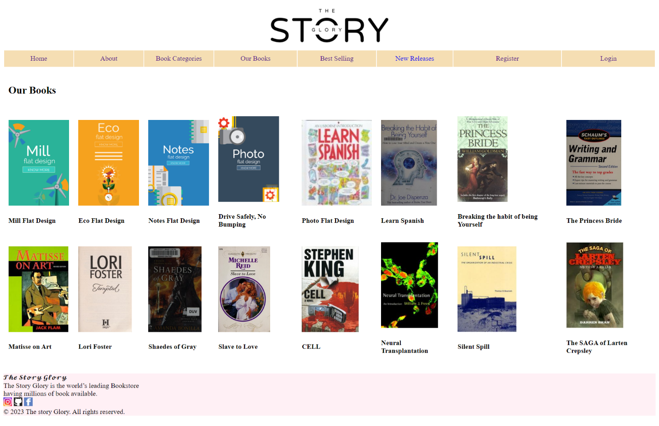

**5.Best Selling:**

**Code-**

**<!DOCTYPE html>**

**<html>**

**<head>**

**<title>Home</title>**

**<style>a{text-decoration:none;}</style>**

**</head>**

**<body>**

**<table style="width:100%">**

**<tr>**

**<td colspan="8" align="center"><img src="images/logo.jpg" style="height:100px;"></td>**

**</tr>**

**<tr style="background:wheat;">**

**<td align="center" style="padding:10px;"><a href="homepage.html">Home</a></td>**

**<td align="center" style="padding:10px;"><a href="about.html">About</a></td>**

**<td align="center" style="padding:10px;"><a href="category.html">Book Categories</a></td>**

**<td align="center" style="padding:10px;"><a href="books.html">Our Books</a></td>**

**<td align="center" style="padding:10px;"><a href="bestselling.html">Best Selling</a></td>**

**<td align="center" style="padding:10px;"><a href="new.html">New Releases</a></td>**

**<td align="center" style="padding:10px;"><a href="signup.html">Register</a></td>**

**<td align="center" style="padding:10px;"><a href="login.html">Login</a></td>**

**</tr>**

**<tr>**

**<td colspan="8" style="padding:20px 10px;"><h2>Best Selling Books</h2></td>**

**</tr>**

**<tr>**

**<td style="padding:5px 10px;">**

**<img src="images/homepage/trend1.jpg" style="height:200px;">**

**<h4>The Tale of Two Cities</h4>**

**</td>**

**<td style="padding:5px 10px;">**

**<img src="images/homepage/trend2.jpg" style="height:200px;">**

**<h4>The Hobbit</h4>**

**</td>**

**<td style="padding:5px 10px;">**

**<img src="images/homepage/trend3.jpg" style="height:200px;">**

**<h4>The Lords of The Rings</h4>**

**</td>**

**<td style="padding:5px 10px;">**

**<img src="images/homepage/trend4.jpg" style="height:200px;">**

**<h4>It Ends With US</h4>**

**</td>**

**<td style="padding:5px 10px;">**

**<img src="images/homepage/trend5.jpg" style="height:200px;">**

**<h4>Breath</h4>**

**</td>**

**<td style="padding:5px 10px;">**

**<img src="images/homepage/trend6.jpg" style="height:200px;">**

**<h4>This Is Not Your Story</h4>**

**</td>**

**<td style="padding:5px 10px;">**

**<img src="images/homepage/trend7.jpg" style="height:200px;">**

**<h4>The Silent Patient</h4>**

**</td>**

**<td style="padding:5px 10px;">**

**<img src="images/homepage/trend8.jpg" style="height:200px;">**

**<h4>The Hidden Hindu</h4>**

**</td>**

**</tr>**

**</table>**

**<footer style="text-align: left;">**

**<p style="background:lavenderblush;">**

**𝓣𝓱𝓮 𝓢𝓽𝓸𝓻𝔂 𝓖𝓵𝓸𝓻𝔂 <br>The Story Glory is the world’s leading Bookstore<br> having millions of book available.**

**<br>**

**<a href="https://www.instagram.com/pankajdagar_/"><img src="images/insta.jpg" alt="insta" height="20"width="20"></a>**

**<a href="https://github.com/Pankajdagar777"><img src="images/git.jpg" alt="github" height="20"width="20"></a>**

**<a href="https://m.facebook.com/"><img src="images/fb.jpg" alt="facebook" height="20"width="20"></a>**

**<br>   © 2023 The story Glory. All rights reserved.**

**</footer>**

**</body>**

**</html>**

**Output:**

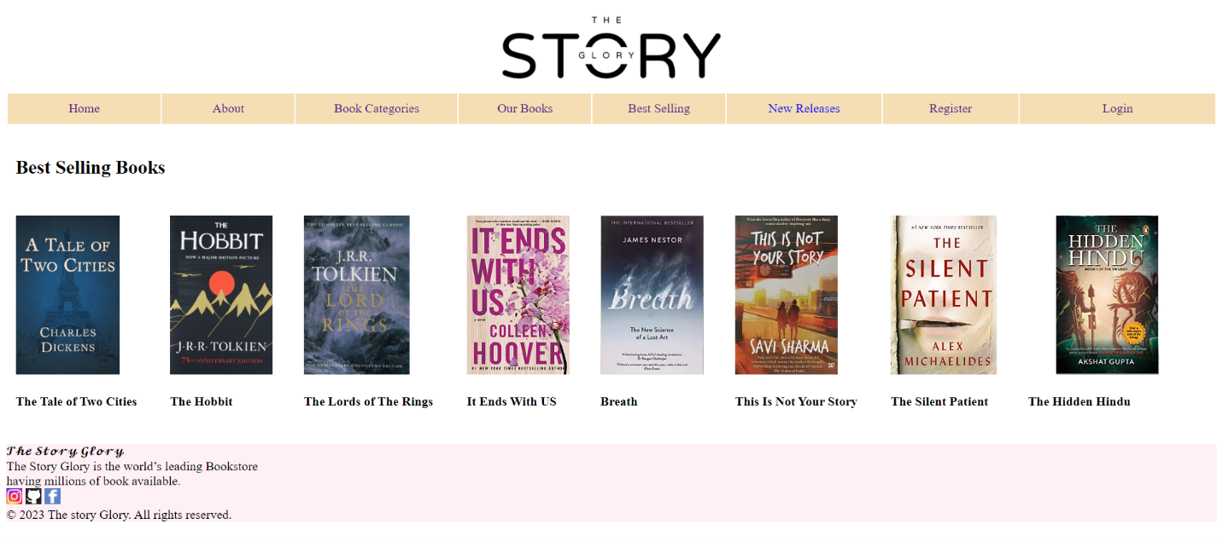

**6.New Release:**

**Code-**

**<!DOCTYPE html>**

**<html>**

**<head>**

**<title>Book Categories</title>**

**<style>a{text-decoration:none;}</style>**

**</head>**

**<body>**

**<table style="width:100%">**

**<tr>**

**<td colspan="8" align="center"><img src="images/logo.jpg" style="height:100px;"></td>**

**</tr>**

**<tr style="background:wheat;">**

**<td align="center" style="padding:10px;"><a href="homepage.html">Home</a></td>**

**<td align="center" style="padding:10px;"><a href="about.html">About</a></td>**

**<td align="center" style="padding:10px;"><a href="category.html">Book Categories</a></td>**

**<td align="center" style="padding:10px;"><a href="books.html">Our Books</a></td>**

**<td align="center" style="padding:10px;"><a href="bestselling.html">Best Selling</a></td>**

**<td align="center" style="padding:10px;"><a href="new.html">New Releases</a></td>**

**<td align="center" style="padding:10px;"><a href="signup.html">Register</a></td>**

**<td align="center" style="padding:10px;"><a href="login.html">Login</a></td>**

**</tr>**

**<tr>**

**<td colspan="8" style="padding:20px 10px;"><h2>New Release Books</h2></td>**

**</tr>**

**<tr>**

**<td colspan="2" style="padding:5px 10px;">**

**<img src="images/new/new1.jpg" style="width:330px; height:300px;">**

**<h3>The love Scribe</h3>**

**</td>**

**<td colspan="2" style="padding:5px 10px;">**

**<img src="images/new/new2.jpg" style="width:330px; height:300px;">**

**<h3>Stone blind</h3>**

**</td>**

**<td colspan="2" style="padding:5px 10px;">**

**<img src="images/new/new3.jpg" style="width:330px; height:300px;">**

**<h3>The Soulmate</h3>**

**</td>**

**<td colspan="2" style="padding:5px 10px;">**

**<img src="images/new/new4.jpg" style="width:330px; height:300px;">**

**<h3>The Fourth Wall</h3>**

**</td>**

**</tr>**

**<tr>**

**<td colspan="2" style="padding:5px 10px;">**

**<img src="images/new/new5.jpg" style="width:330px; height:300px;">**

**<h3>The Narrow</h3>**

**</td>**

**<td colspan="2" style="padding:5px 10px;">**

**<img src="images/new/new6.jpg" style="width:330px; height:300px;">**

**<h3>Hell Bent Leigh</h3>**

**</td>**

**<td colspan="2" style="padding:5px 10px;">**

**<img src="images/new/new7.jpg" style="width:330px; height:300px;">**

**<h3> As Bright As Heaven</h3>**

**</td>**

**<td colspan="2" style="padding:5px 10px;">**

**<img src="images/new/new8.jpg" style="width:330px; height:300px;">**

**<h3>Past Heaven</h3>**

**</td>**

**</tr>**

**</table>**

**<footer style="text-align: left;">**

**<p style="background:lavenderblush;">**

**𝓣𝓱𝓮 𝓢𝓽𝓸𝓻𝔂 𝓖𝓵𝓸𝓻𝔂 <br>The Story Glory is the world’s leading Bookstore<br> having millions of book available.**

**<br>**

**<a href="https://www.instagram.com/pankajdagar_/"><img src="images/insta.jpg" alt="insta" height="20"width="20"></a>**

**<a href="https://github.com/Pankajdagar777"><img src="images/git.jpg" alt="github" height="20"width="20"></a>**

**<a href="https://m.facebook.com/"><img src="images/fb.jpg" alt="facebook" height="20"width="20"></a>**

**<br>   © 2023 The story Glory. All rights reserved.**

**</footer>**

**</body>**

**</html>**

**Output:**

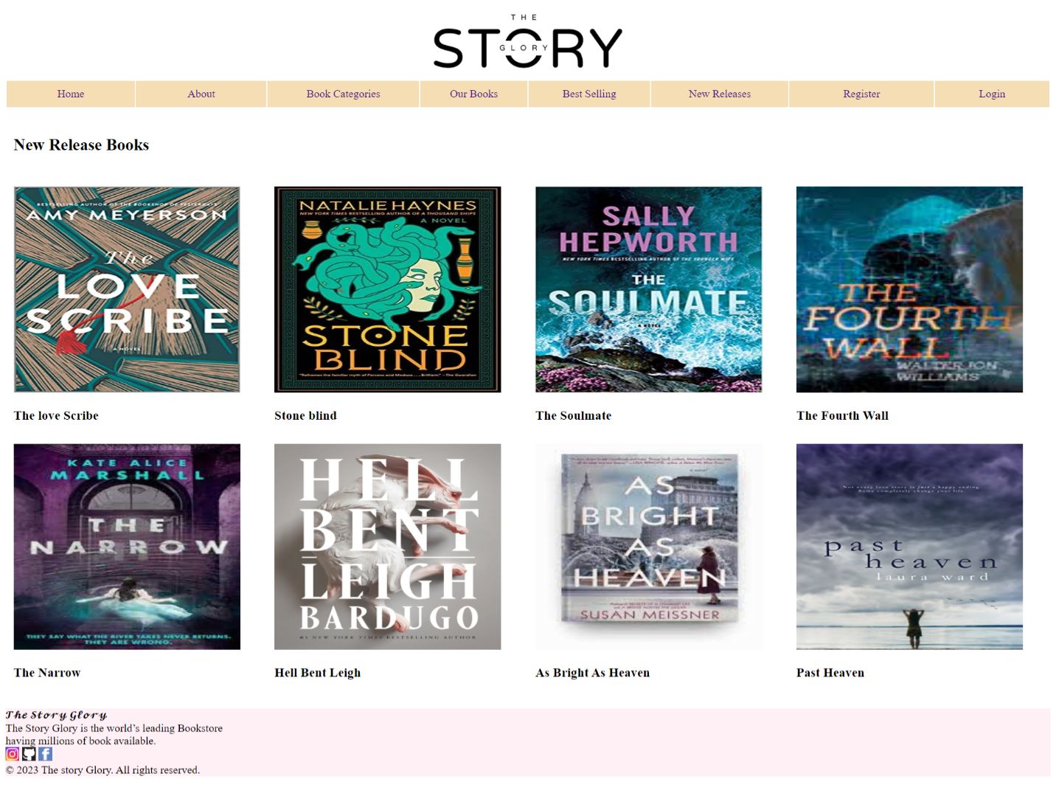

**7.Register:**

**Code-**

**<!DOCTYPE html>**

**<html>**

**<head>**

**<title>Home</title>**

**<style>**

**a**

**{**

**text-decoration:none;**

**}**

**</style>**

**</head>**

**<body>**

**<table style="width:100%">**

**<tr>**

**<td colspan="8" align="center"><img src="images/logo.jpg" style="height:100px;"></td>**

**</tr>**

**<tr style="background:wheat;">**

**<td align="center" style="padding:10px;"><a href="homepage.html">Home</a></td>**

**<td align="center" style="padding:10px;"><a href="about.html">About</a></td>**

**<td align="center" style="padding:10px;"><a href="category.html">Book Categories</a></td>**

**<td align="center" style="padding:10px;"><a href="books.html">Our Books</a></td>**

**<td align="center" style="padding:10px;"><a href="bestselling.html">Best Selling</a></td>**

**<td align="center" style="padding:10px;"><a href="new.html">New Releases</a></td>**

**<td align="center" style="padding:10px;"><a href="signup.html">Register</a></td>**

**<td align="center" style="padding:10px;"><a href="login.html">Login</a></td>**

**</tr>**

**<tr>**

**<td align="center" colspan="8"><h2>Create your account</h2></td>**

**</tr>**

**<form action = "/action.php">**

**<tr>**

**<td align="center" colspan="8"><h4>Name</h4></td>**

**</tr>**

**<tr>**

**<td align="center" colspan="8"><input type=text name=textnames id="textname" size="30" placeholder="Name"></td>**

**</tr>**

**<tr>**

**<td align="center" colspan="8"><h4>Phone No.</h4></td>**

**</tr>**

**<tr>**

**<td align="center" colspan="8"><input type="text" name="Phone no." id="Phone No." size="30" placeholder="Phone no. no."></td>**

**</tr>**

**<tr>**

**<td align="center" colspan="8"><h4>E-mail</h4></td>**

**</tr>**

**<tr>**

**<td align="center" colspan="8"><input type="text" name="E-mail" id="E-mail" size="30" placeholder="E-mail"></td>**

**</tr>**

**<tr>**

**<td align="center" colspan="8"><h4>DOB</h4></td>**

**</tr>**

**<tr>**

**<td align="center" colspan="8"><input type="date name="DOB" id="DOB" size="30" placeholder="DOB"></td>**

**</tr>**

**<tr>**

**<td align="center" colspan="8"><h4>Password</h4></td>**

**</tr>**

**<tr>**

**<td align="center" colspan="8"><input type="password" name="Password" id="Password" size="30" placeholder="Password"  </td>**

**</tr>**

**<tr>**

**<td align="center" colspan="8"><h4>Confirm Password</h4></td>**

**</tr>**

**<tr>**

**<td align="center" colspan="8" ><input type="password" name="Confirm Password" id="Confirm Password" size="30" placeholder="Confirm Password"  </td>**

**</tr>**

**<tr>**

**<td colspan="8" align="center"><input type="submit" value="Sign Up" /></td>**

**</tr>**

**</form>**

**</table>**

**<footer style="text-align: left;">**

**<p style="background:lavenderblush;">**

**𝓣𝓱𝓮 𝓢𝓽𝓸𝓻𝔂 𝓖𝓵𝓸𝓻𝔂 <br>The Story Glory is the world’s leading Bookstore<br> having millions of book available.**

**<br>**

**<a href="https://www.instagram.com/pankajdagar_/"><img src="images/insta.jpg" alt="insta" height="20"width="20"></a>**

**<a href="https://github.com/Pankajdagar777"><img src="images/git.jpg" alt="github" height="20"width="20"></a>**

**<a href="https://m.facebook.com/"><img src="images/fb.jpg" alt="facebook" height="20"width="20"></a>**

**<br>   © 2023 The story Glory. All rights reserved.**

**</footer>**

**</body>**

**</html>**

**Output:**

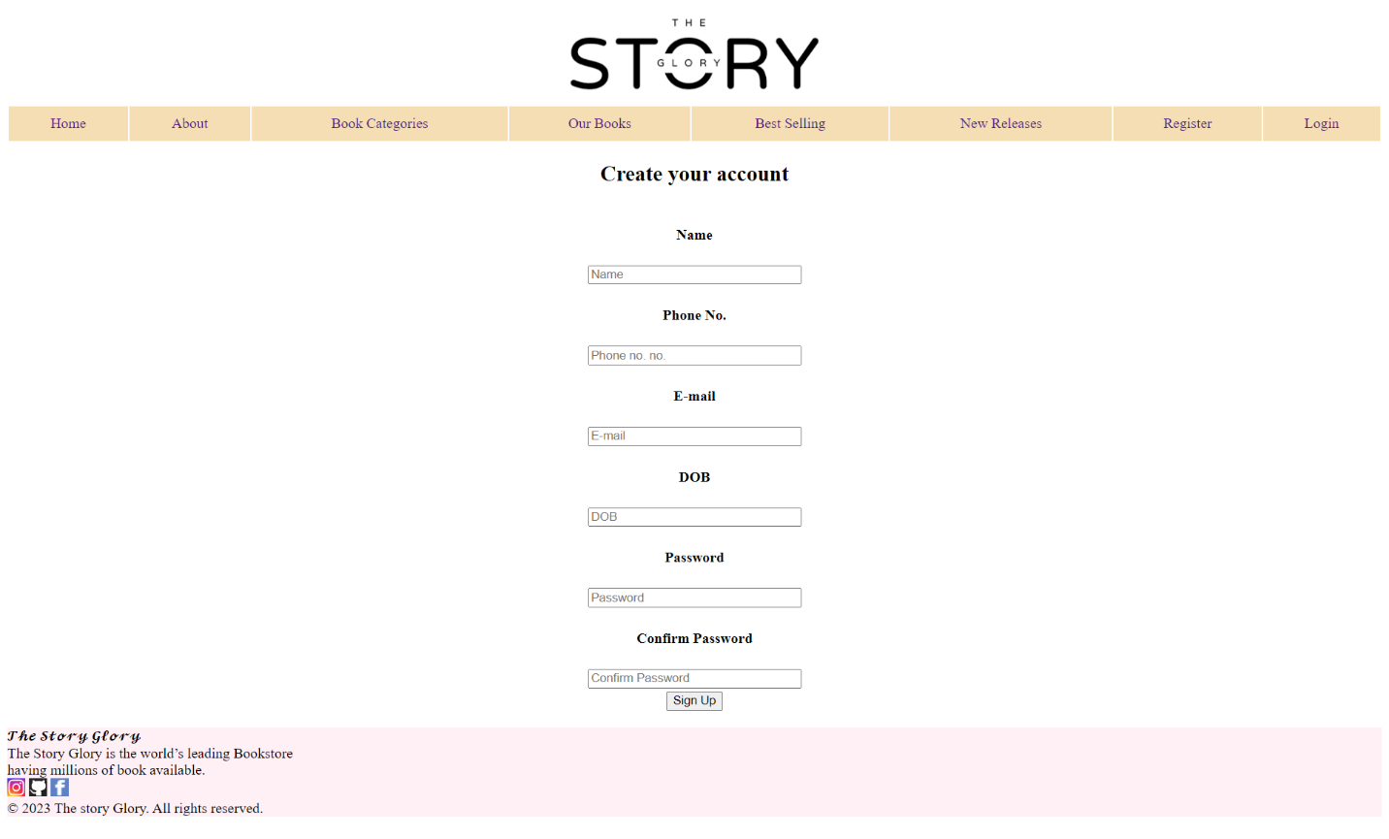

**8.Login:**

**Code-**

**<!DOCTYPE html>**

**<html>**

**<head>**

**<title>Home</title>**

**<style>a{text-decoration:none;}</style>**

**</head>**

**<body>**

**<table style="width:100%">**

**<tr>**

**<td colspan="8" align="center"><img src="images/logo.jpg" style="height:100px;"></td>**

**</tr>**

**<tr style="background:wheat;">**

**<td align="center" style="padding:10px;"><a href="homepage.html">Home</a></td>**

**<td align="center" style="padding:10px;"><a href="about.html">About</a></td>**

**<td align="center" style="padding:10px;"><a href="category.html">Book Categories</a></td>**

**<td align="center" style="padding:10px;"><a href="books.html">Our Books</a></td>**

**<td align="center" style="padding:10px;"><a href="bestselling.html">Best Selling</a></td>**

**<td align="center" style="padding:10px;"><a href="new.html">New Releases</a></td>**

**<td align="center" style="padding:10px;"><a href="signup.html">Register</a></td>**

**<td align="center" style="padding:10px;"><a href="login.html">Login</a></td>**

**</tr>**

**<tr>**

**<td align="center" colspan="8"><h2>Welcome to The Story Glory!!</h2></td>**

**</tr>**

**<tr>**

**<td align="center" colspan="8"><h2>Login to Your Account</h2></td>**

**</tr>**

**<form action = "/action.php">**

**<tr>**

**<td align="center" colspan="8"><h4>Username</h4></td>**

**</tr>**

**<tr>**

**<td align="center" colspan="8"><input type=text name=textnames id="textname" size="30" placeholder="Username"></td>**

**</tr>**

**<tr>**

**<td align="center" colspan="8"><h4>Password</h4></td>**

**</tr>**

**<tr>**

**<td align="center" colspan="8"><input type="password" name="Password" id="Password" size="30" placeholder="Password"  </td>**

**</tr>**

**<tr>**

**<td colspan="8" align="center"><input type="submit" value="Login" /></td>**

**</tr>**

**</table>**

**<footer style="text-align: left;">**

**<p style="background:lavenderblush;">**

**𝓣𝓱𝓮 𝓢𝓽𝓸𝓻𝔂 𝓖𝓵𝓸𝓻𝔂 <br>The Story Glory is the world’s leading Bookstore<br> having millions of book available.**

**<br>**

**<a href="https://www.instagram.com/pankajdagar_/"><img src="images/insta.jpg" alt="insta" height="20"width="20"></a>**

**<a href="https://github.com/Pankajdagar777"><img src="images/git.jpg" alt="github" height="20"width="20"></a>**

**<a href="https://m.facebook.com/"><img src="images/fb.jpg" alt="facebook" height="20"width="20"></a>**

**<br>   © 2023 The story Glory. All rights reserved.**

**</footer>**

**</body>**

**</html>**

**Output:**

